Professor Tong Yi

Selina Zheng

CSCI 12700

**Neighborhood Analysis: Sunset Park**

**Citation:** [https://eportfolios.macaulay.cuny.edu](https://eportfolios.macaulay.cuny.edu/berger2010/sunset-park-brooklyn/) **Citation**: [https://www.nytimes.com/2021/04/](https://www.nytimes.com/2021/04/13/nyregion/brooklyn-sunset-park-covid.html)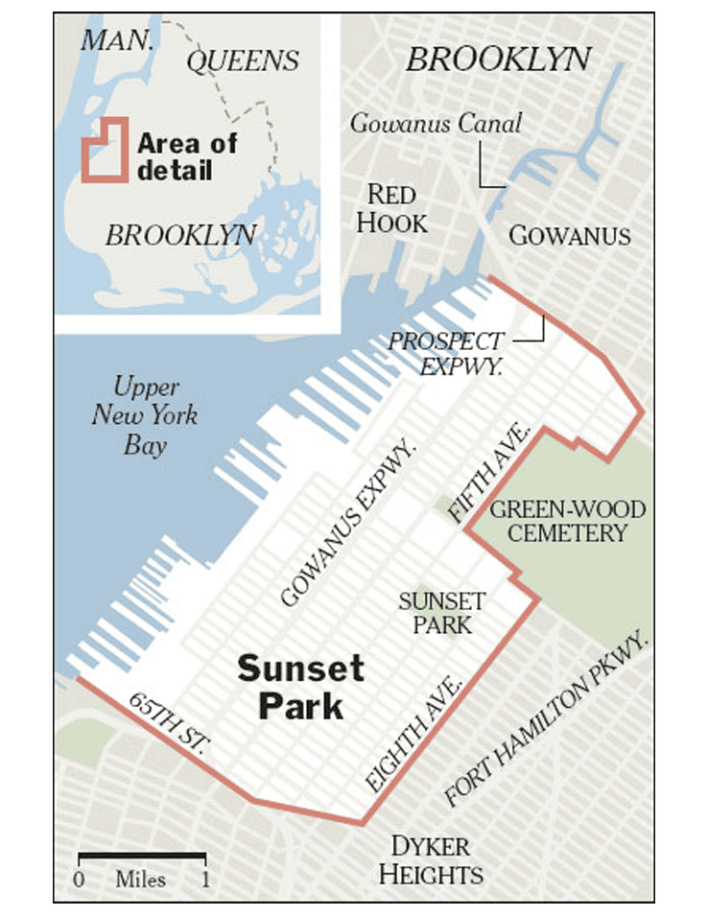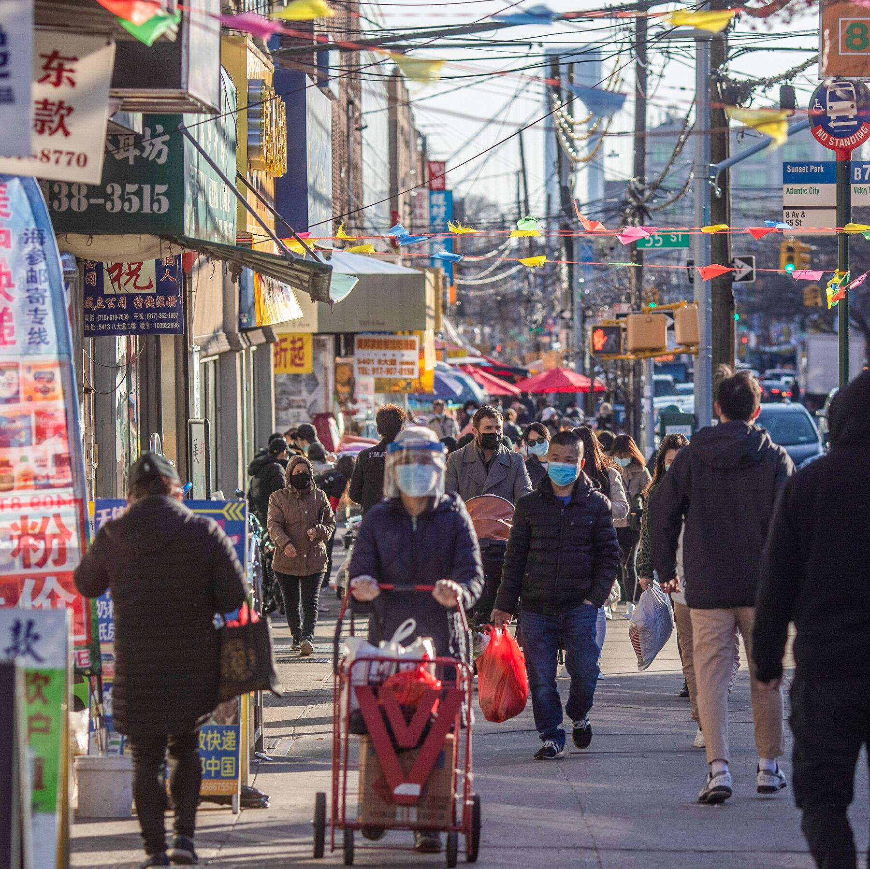

[/berger2010/sunset-park-brooklyn/](https://eportfolios.macaulay.cuny.edu/berger2010/sunset-park-brooklyn/) [13/nyregion/brooklyn-sunset-park-covid.html](https://www.nytimes.com/2021/04/13/nyregion/brooklyn-sunset-park-covid.html)

For our project, my group chose to study Brooklyn. I am specifically analyzing the neighborhood of Sunset Park, with the zip code 11220. Sunset Park is a cultural hotspot with a population of 34.8% Asian, 3.9% Black, 35.6% Hispanic, and 23.7% white in 2019. It has a broad spectrum of residents across education levels (with most holding less than a high school diploma), gender (an almost even split), and age (21% of residents are 25-34 years old).

21.4% of households lie within the $100,001 - $250,000 range, the largest group. The median income was $71,320 and Sunset Park has a poverty rate of 18.1%, slightly higher than the city’s average of 16%. Serious crime rates are lower than the city’s on average with 9.5 per every 1,000 residents as opposed to 12.2 per every 1000 residents. Homeownership was 30.7%, lower than the citywide share of 31.9%, but is gradually increasing, having gone up by 3.9% since 2010.

**Citation:**

* <https://furmancenter.org/neighborhoods/view/sunset-park>
* <https://www.niche.com/places-to-live/n/sunset-park-new-york-city-ny/residents/>